WIJAYAWARDHANA W.A.H.A.

2019/E/166

SEMESTER 05

13 OCTOBER 2022

LAB 04

EC 5070 – DATABASE SYSTEMS

01.

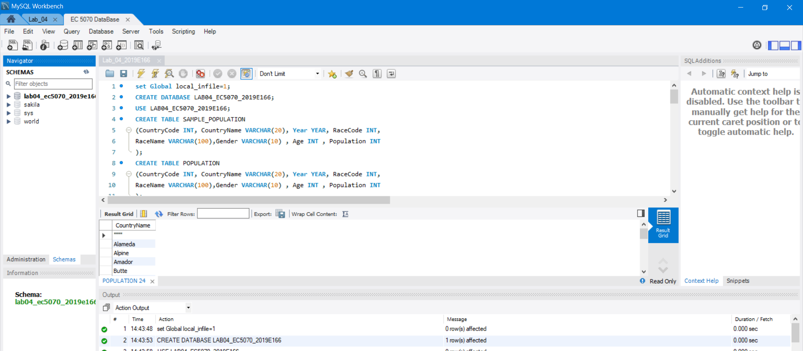

FIGURE 01 – CREATE DATABASE

02.

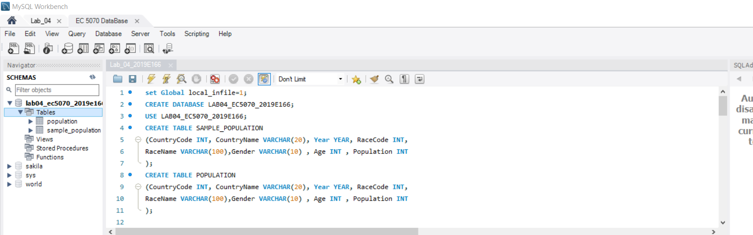

FIGURE 02 – CREATE TABLE



FIGURE 03 – CREATE TABLE

03.

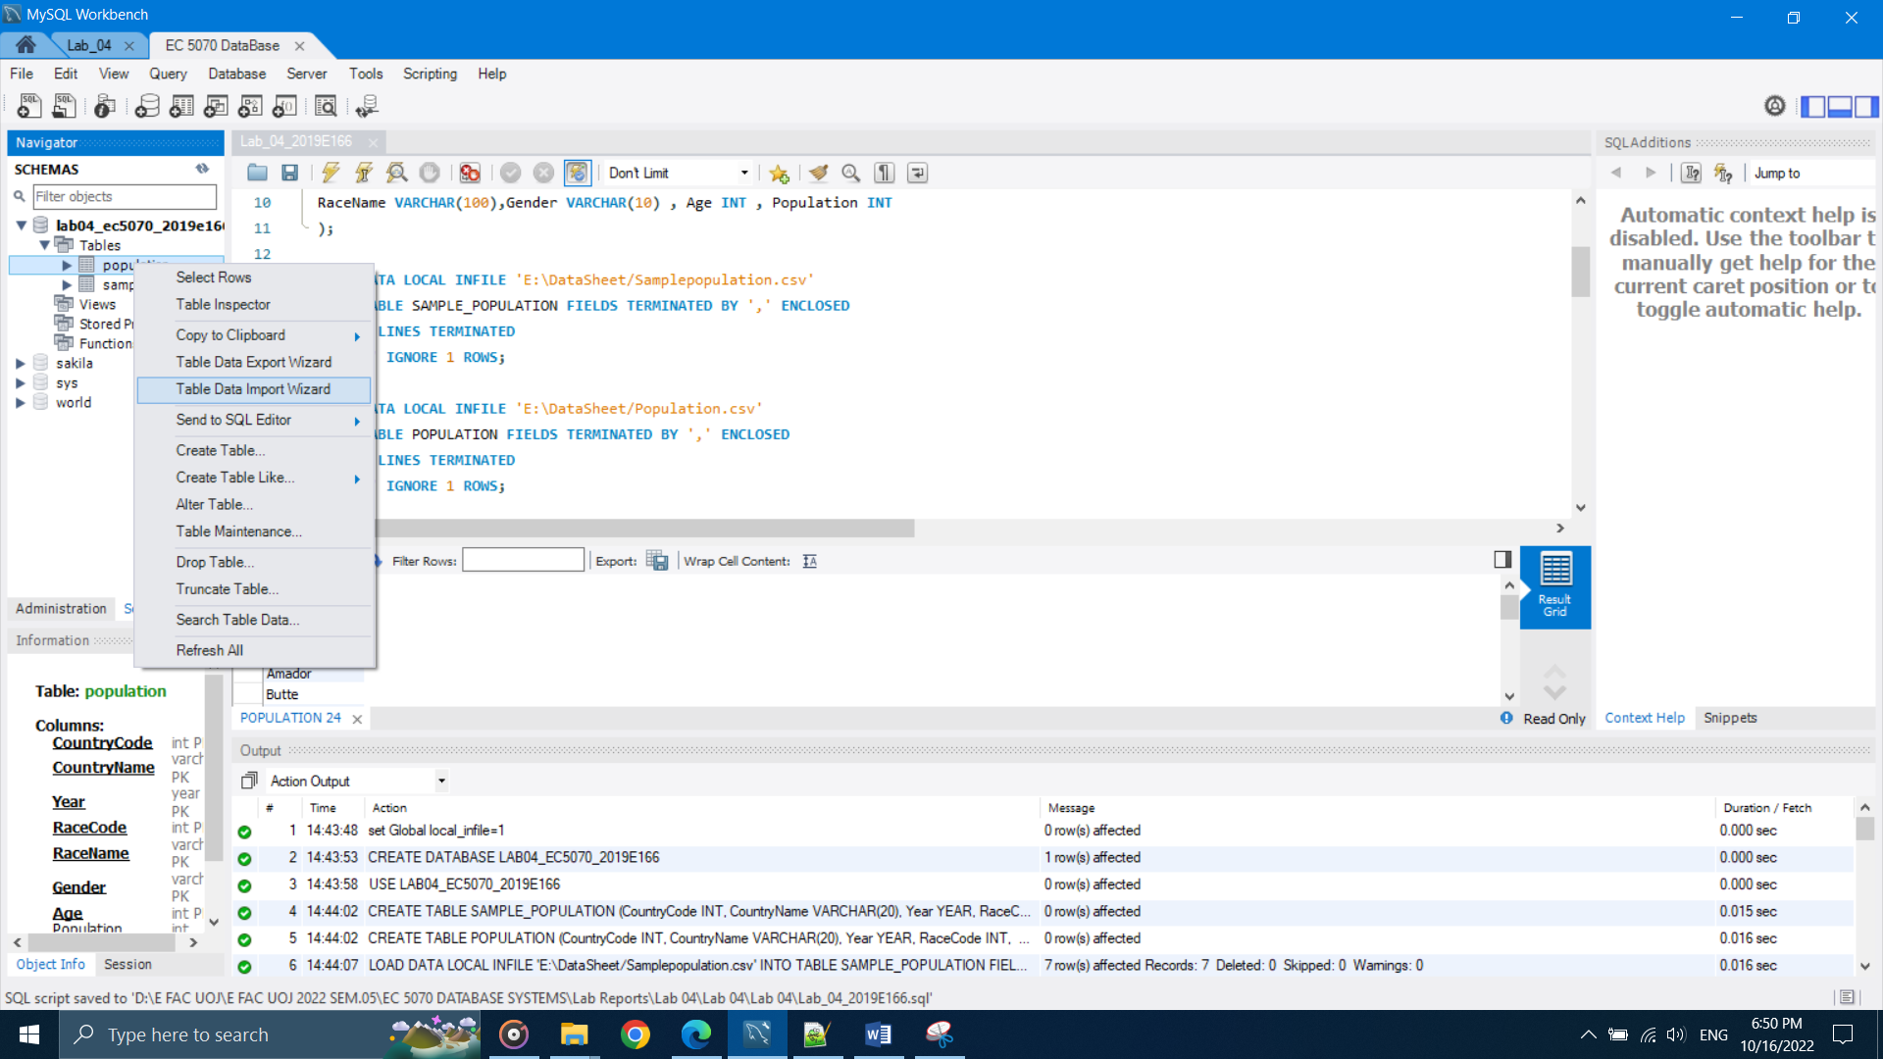

FIGURE 04 – IMPORT DATA USING IMPORT DATA WIZARD

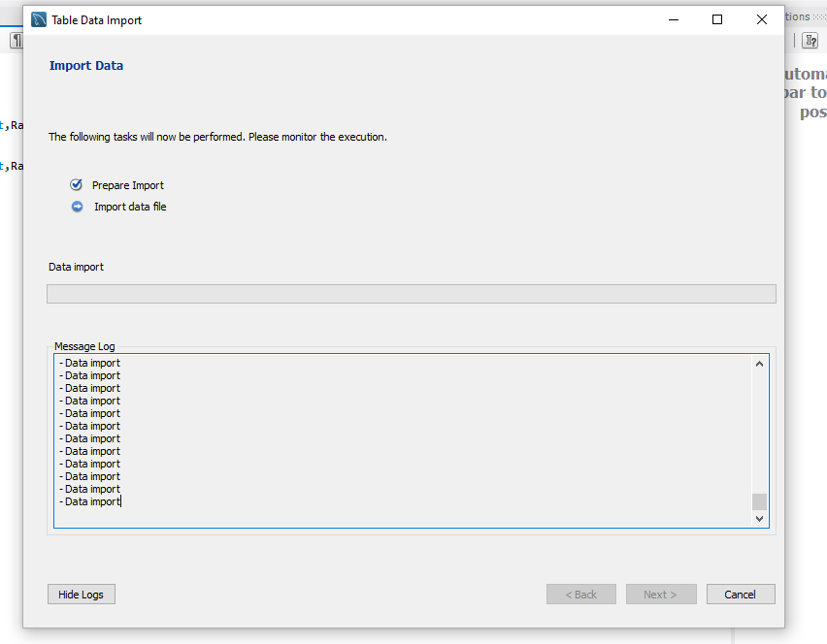

FIGURE 05 – IMPORT DATA USING IMPORT DATA WIZARD

04.

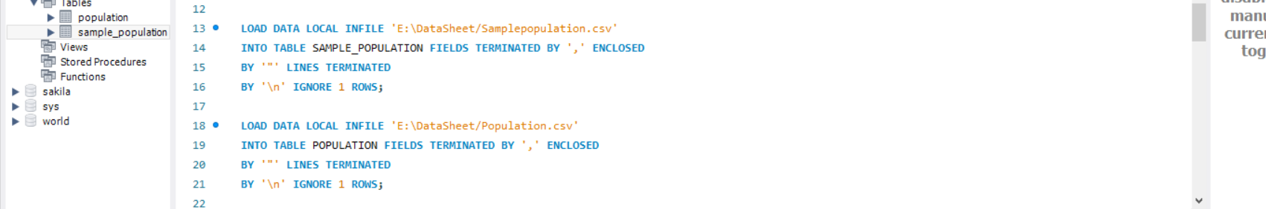

FIGURE 06 – IMPORT DATA USING QUERIES



FIGURE 07 – IMPORT DATA USING QUERIES

05.

When data import from the import data wizard method it take more time. For small data importing this method is ok but when we importing big data sheet to a file this method is not a good method. For large file it take more time for importing data.

When queries use for data importing it is a good solution for big data importing. It take less time than import data wizard method.

Main different between these two methods is the time taken for importing data for big data files.

06.

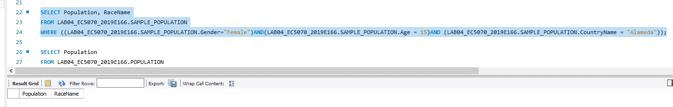

FIGURE 08 – QUERY 01 FOR SAMPLE POPULATION TABLE



FIGURE 09 – TIME DURATION FOR QUERY 01 FOR SAMPLE POPULATION TABLE

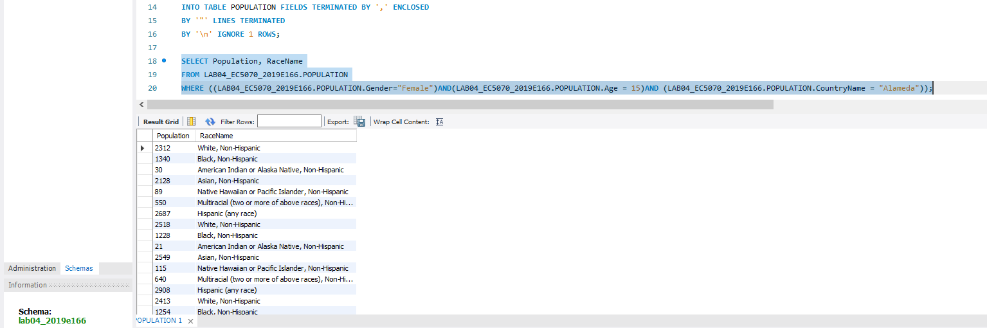

FIGURE 10 – QUERY 01 FOR POPULATION TABLE



FIGURE 11 – TIME DURATION FOR QUERY 01 FOR POPULATION TABLE

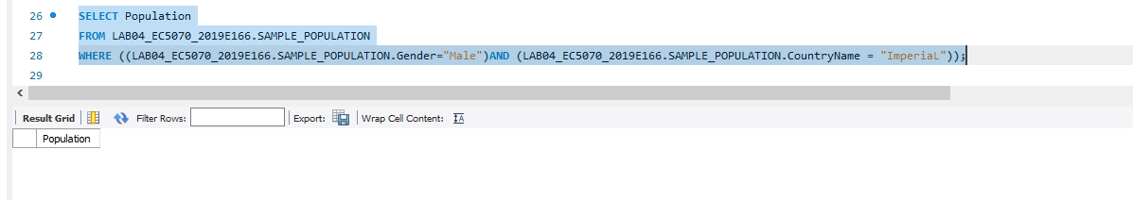

FIGURE 12 – QUERY 02 FOR SAMPLE POPULATION TABLE



FIGURE 13 – TIME DURATION FOR QUERY 02 FOR SAMPLE POPULATION TABLE

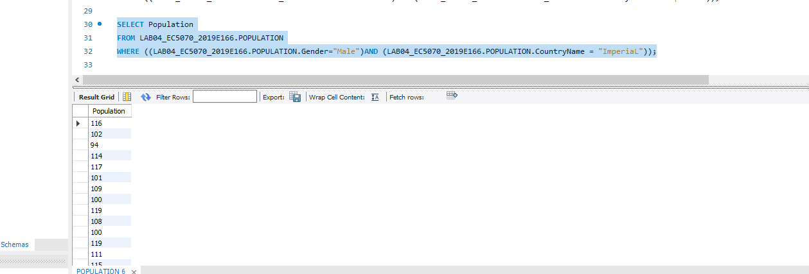

FIGURE 14 – QUERY 02 FOR POPULATION TABLE



FIGURE 15 – TIME DURATION FOR QUERY 02 FOR POPULATION TABLE

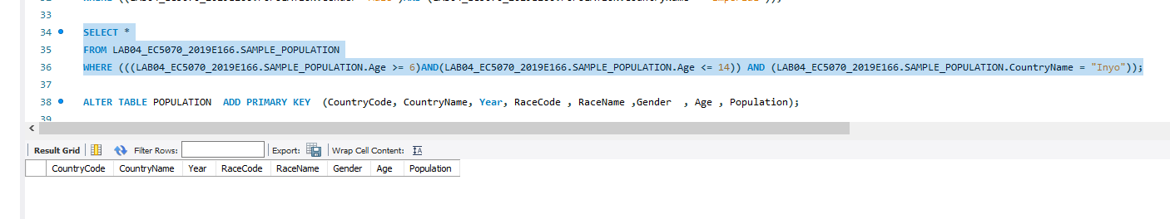

FIGURE 16 – QUERY 03 FOR SAMPLE POPULATION TABLE



FIGURE 17 – TIME DURATION FOR QUERY 03 FOR SAMPLE POPULATION TABLE

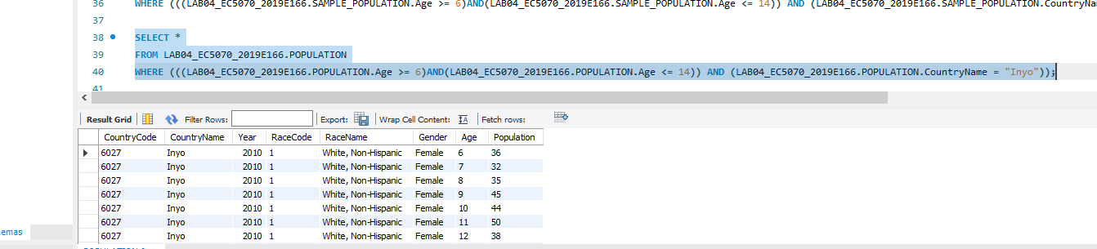

FIGURE 18 – QUERY 03 FOR POPULATION TABLE



FIGURE 19 – TIME DURATION FOR QUERY 03 FOR POPULATION TABLE

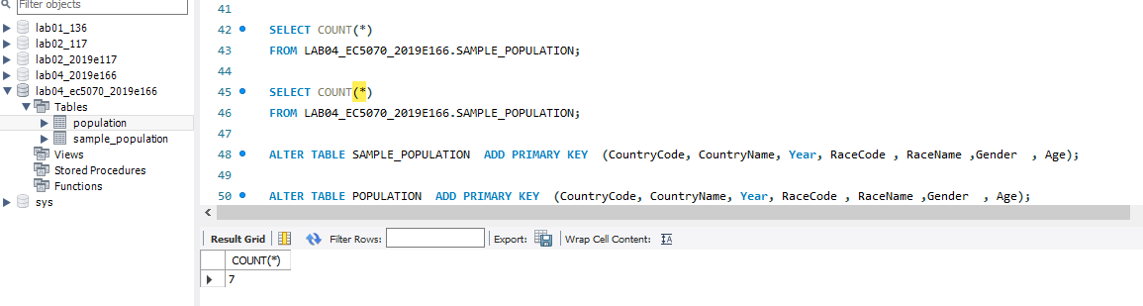

FIGURE 20 – QUERY 04 FOR SAMPLE POPULATION TABLE



FIGURE 21 – TIME DURATION FOR QUERY 04 FOR SAMPLE POPULATION TABLE

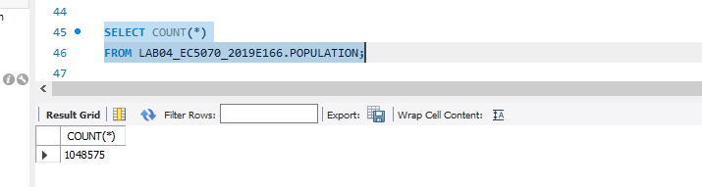

FIGURE 22 – QUERY 04 FOR POPULATION TABLE



FIGURE 23 – TIME DURATION FOR QUERY 04 FOR POPULATION TABLE

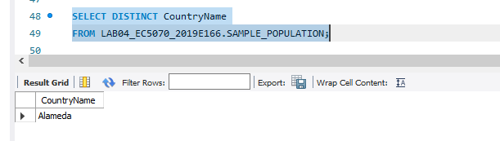

FIGURE 24 – QUERY 05 FOR SAMPLE POPULATION TABLE



FIGURE 25 – TIME DURATION FOR QUERY 05 FOR SAMPLE POPULATION TABLE

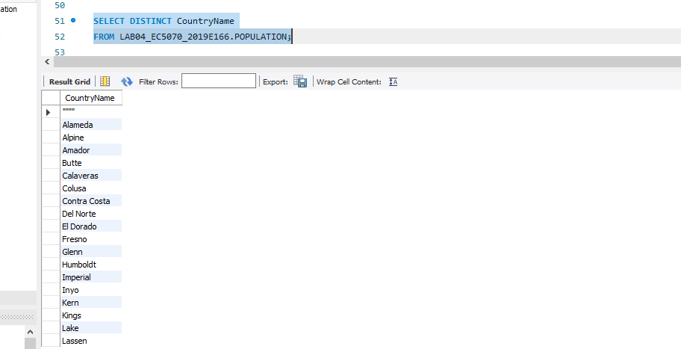

FIGURE 26 – QUERY 05 FOR POPULATION TABLE



FIGURE 27 – TIME DURATION FOR QUERY 05 FOR POPULATION TABLE

07.



FIGURE 28 – CREATE PRIMARY KEY FOR TABLE



FIGURE 29 – TIME DURATION FOR CREATEING PRIMARY KEY FOR TABLE

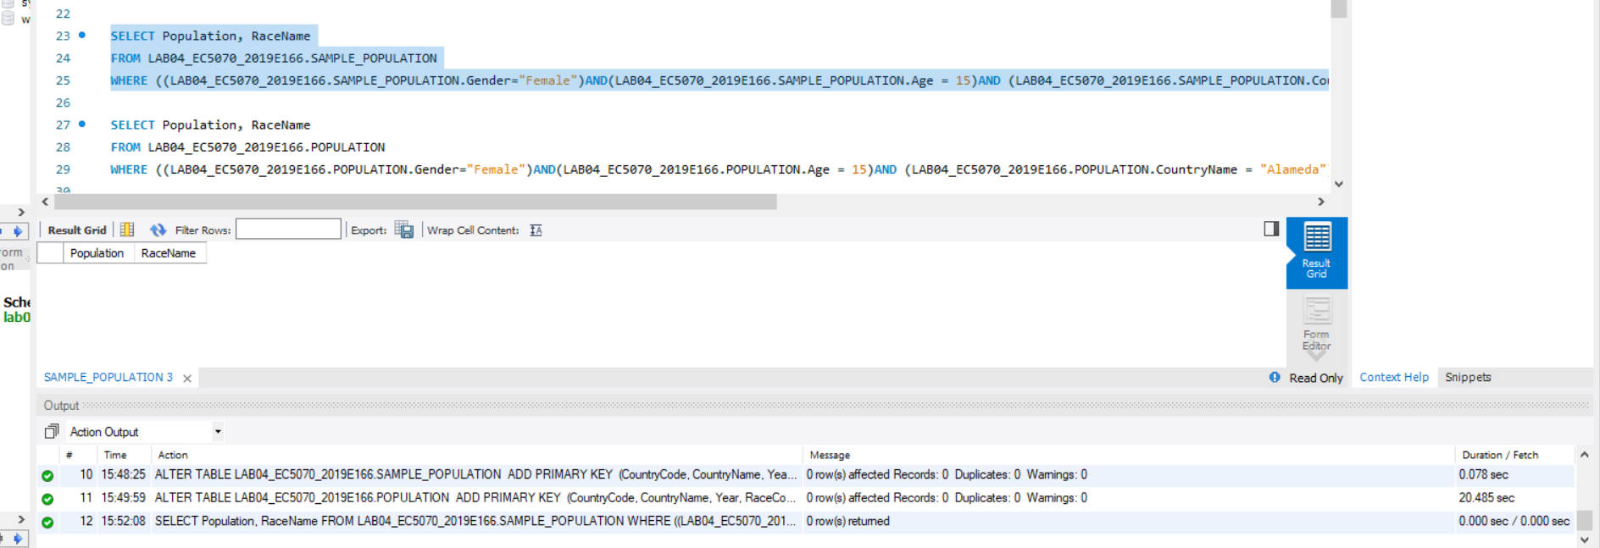

FIGURE 30 – QUERY 01 & TIME DURATION FOR SAMPLE POPULATION TABLE AFTER ADD PRIMARY KEY

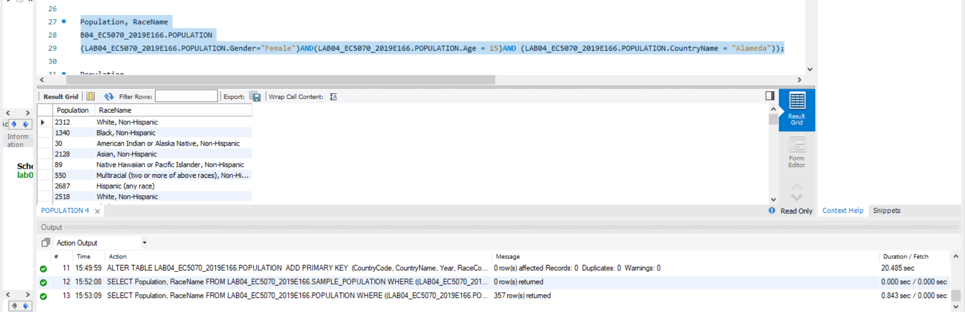

FIGURE 31 – QUERY 01 & TIME DURATION FOR POPULATION TABLE AFTER ADD PRIMARY KEY

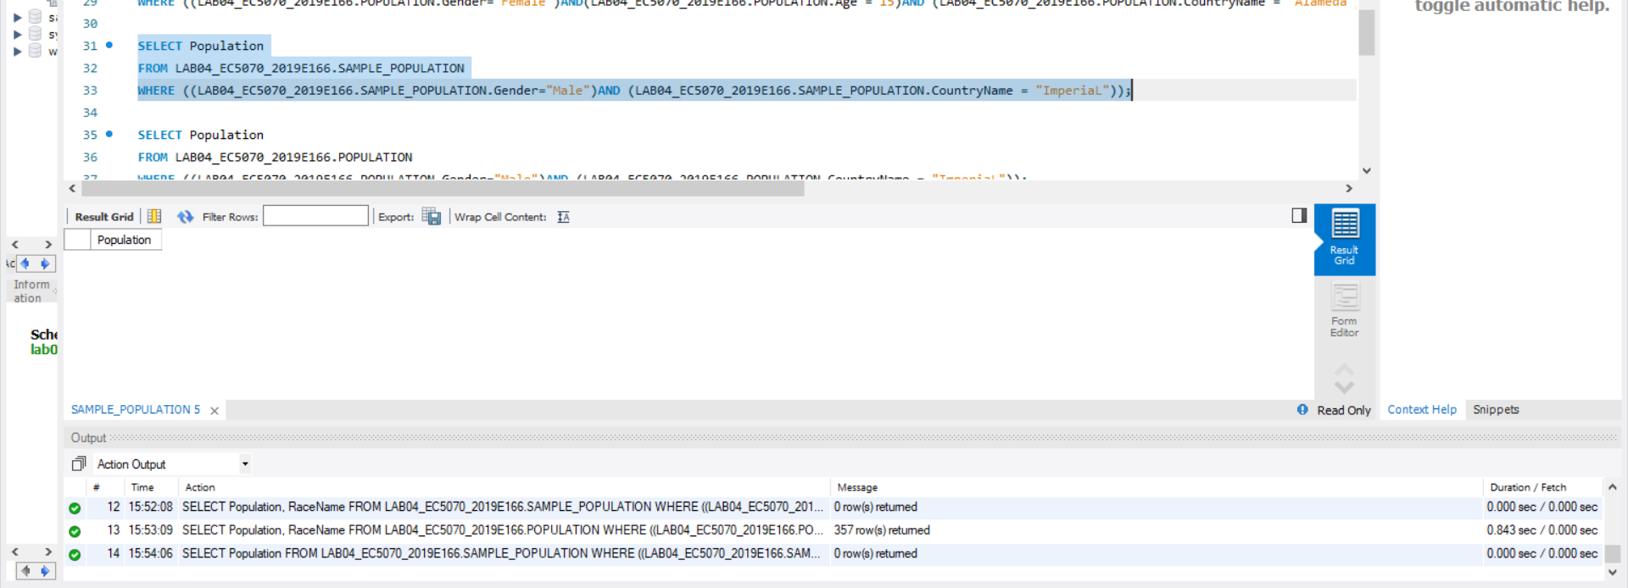

FIGURE 32 – QUERY 02 & TIME DURATION FOR SAMPLE POPULATION TABLE AFTER ADD PRIMARY KEY

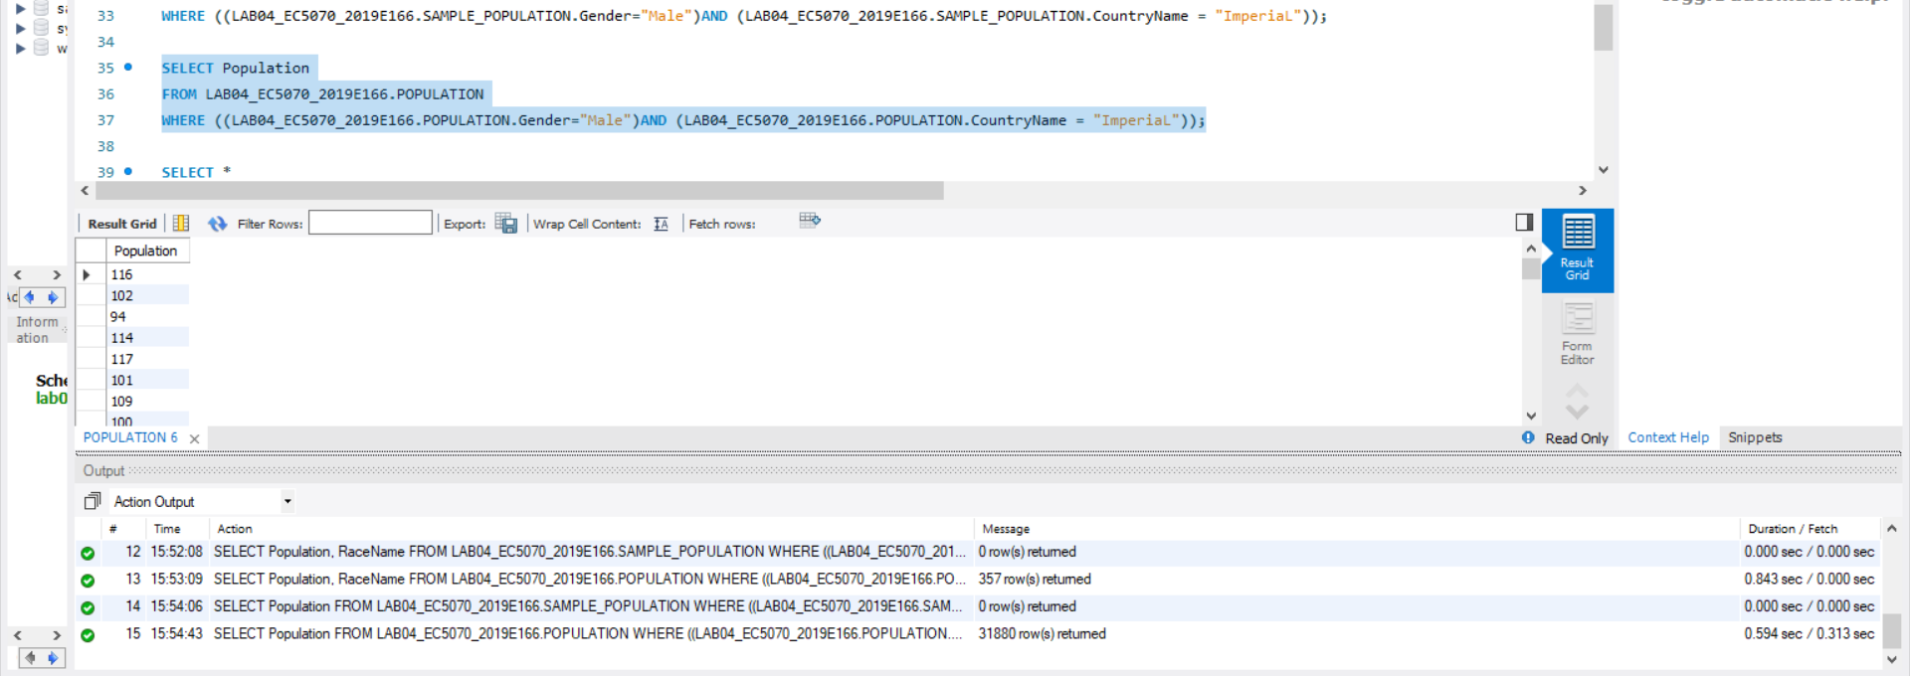

FIGURE 33 – QUERY 02 & TIME DURATION FOR POPULATION TABLE AFTER ADD PRIMARY KEY

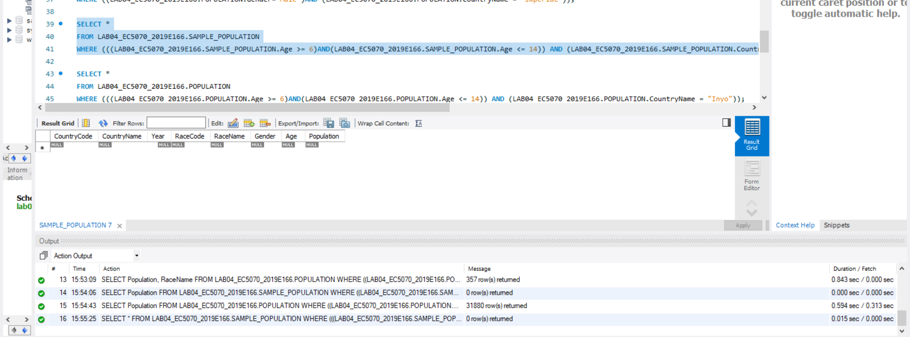

FIGURE 34 – QUERY 03 & TIME DURATION FOR SAMPLE POPULATION TABLE AFTER ADD PRIMARY KEY

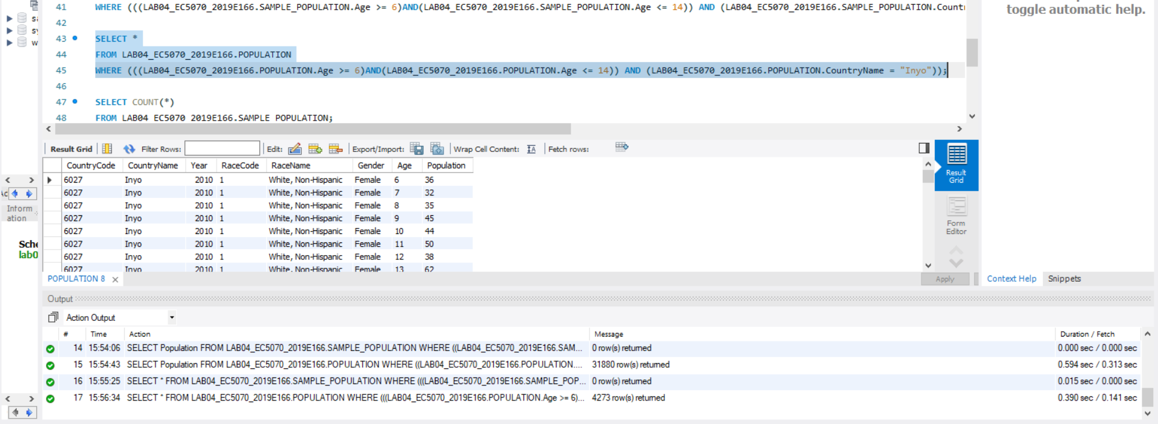

FIGURE 35 – QUERY 03 & TIME DURATION FOR POPULATION TABLE AFTER ADD PRIMARY KEY

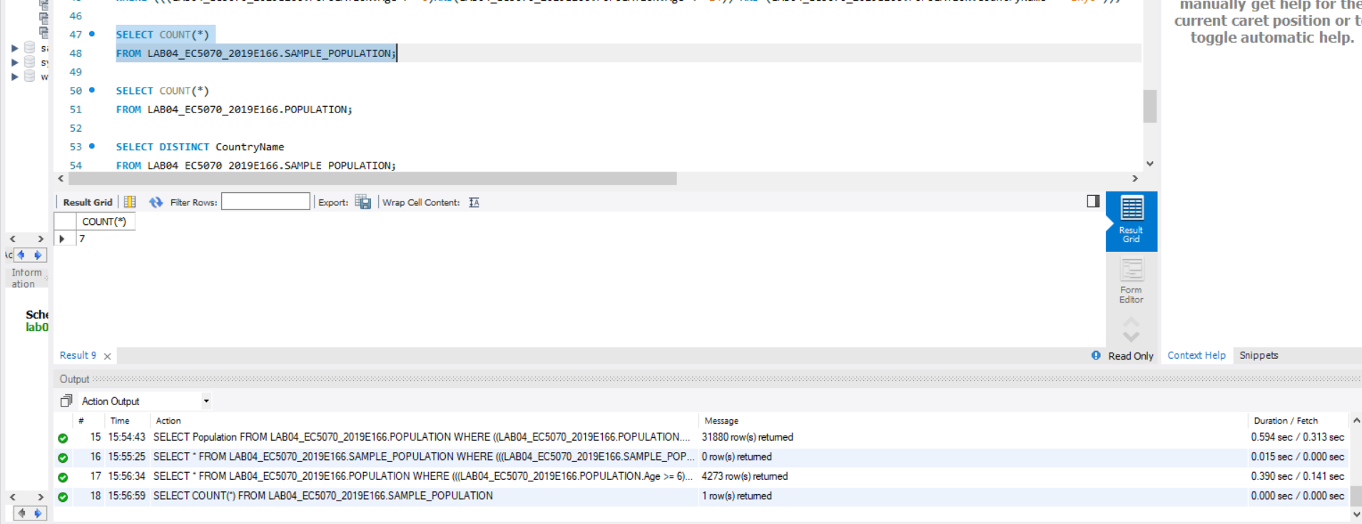

FIGURE 36 – QUERY 04 & TIME DURATION FOR SAMPLE POPULATION TABLE AFTER ADD PRIMARY KEY

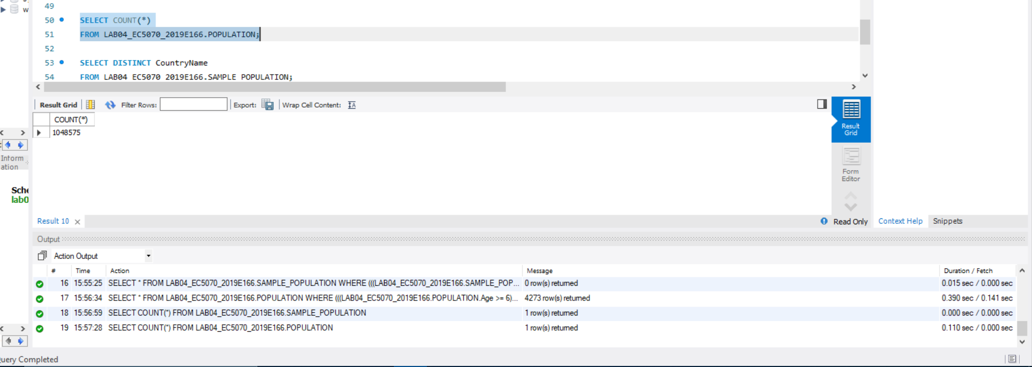

FIGURE 37 – QUERY 04 & TIME DURATION FOR POPULATION TABLE AFTER ADD PRIMARY KEY

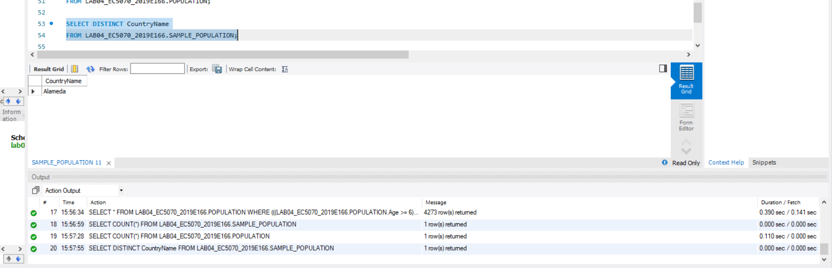

FIGURE 38 – QUERY 05 & TIME DURATION FOR SAMPLE POPULATION TABLE AFTER ADD PRIMARY KEY

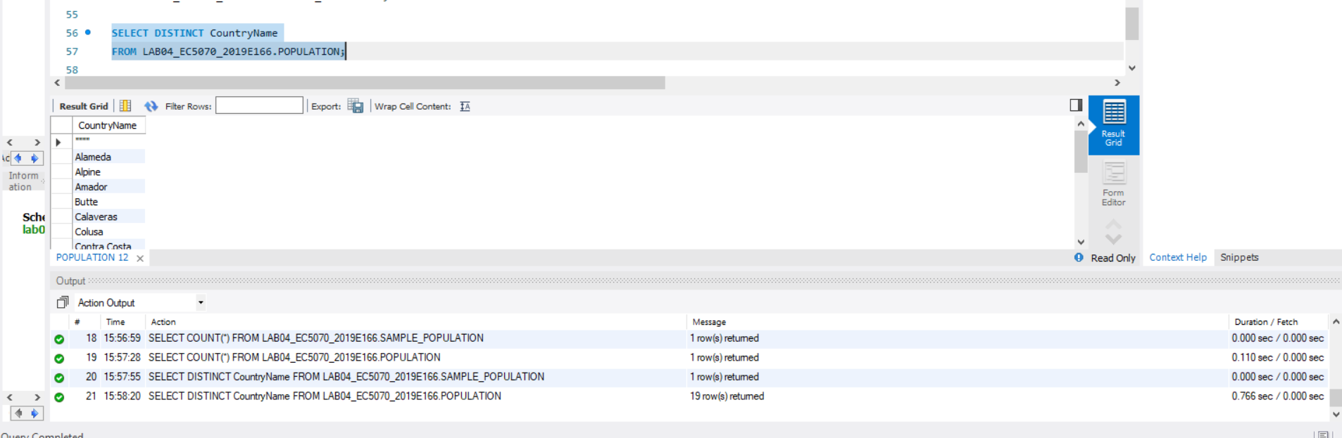

FIGURE 39 – QUERY 05 & TIME DURATION FOR POPULATION TABLE AFTER ADD PRIMARY KEY

08.

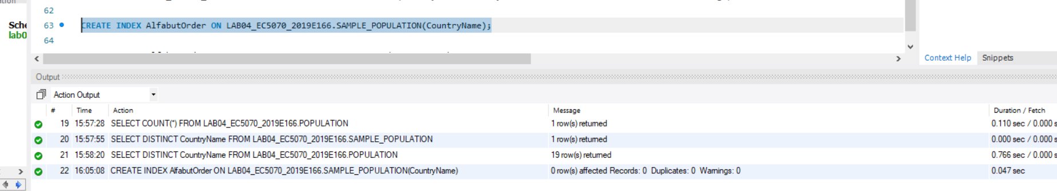

FIGURE 40 – CREATE THE SECONDARY INDEX FOR SAMPLE POPULATION TABLE

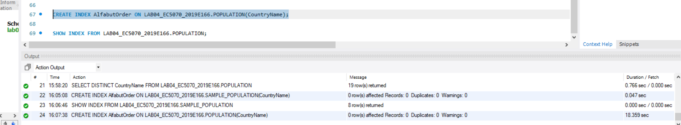

FIGURE 41 – CREATE THE SECONDARY INDEX FOR POPULATION TABLE

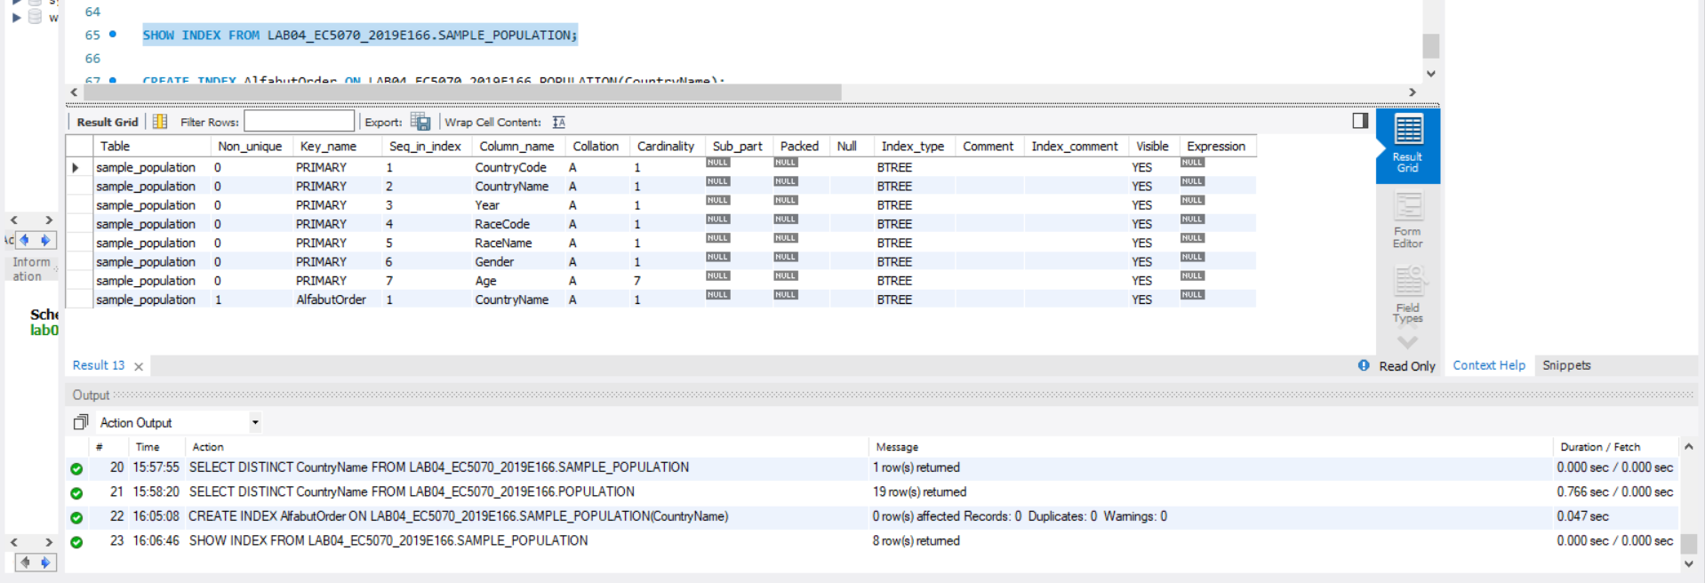

FIGURE 42 – SHOW INDEX FROM SAMPLE POPULATION TABLE

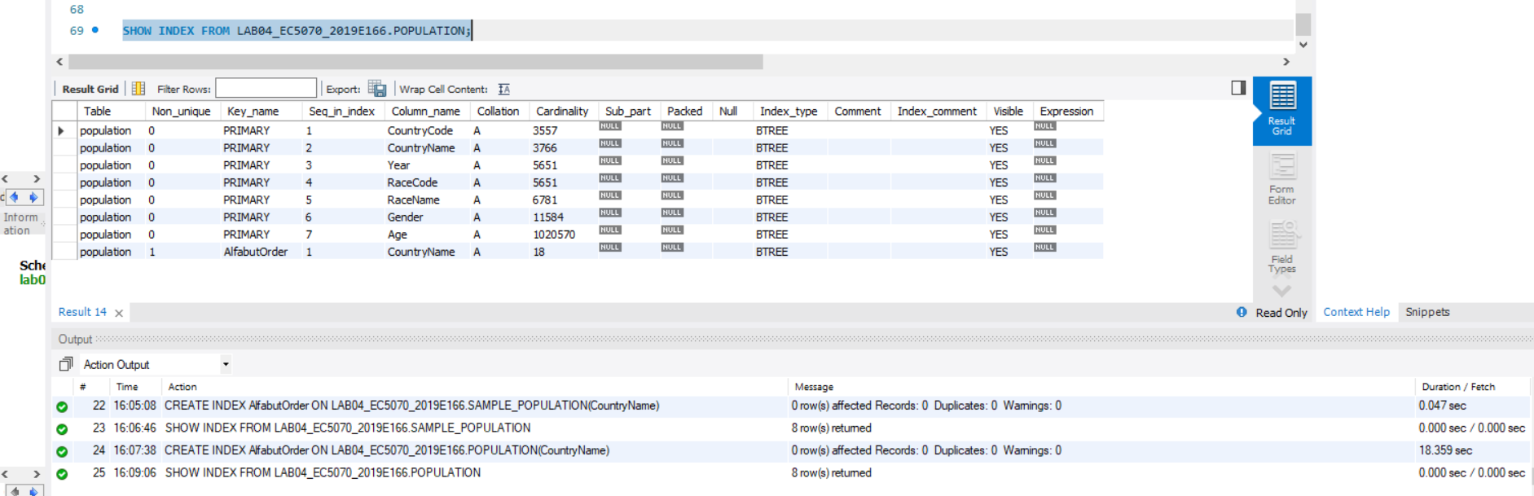

FIGURE 43 – SHOW INDEX FROM POPULATION TABLE

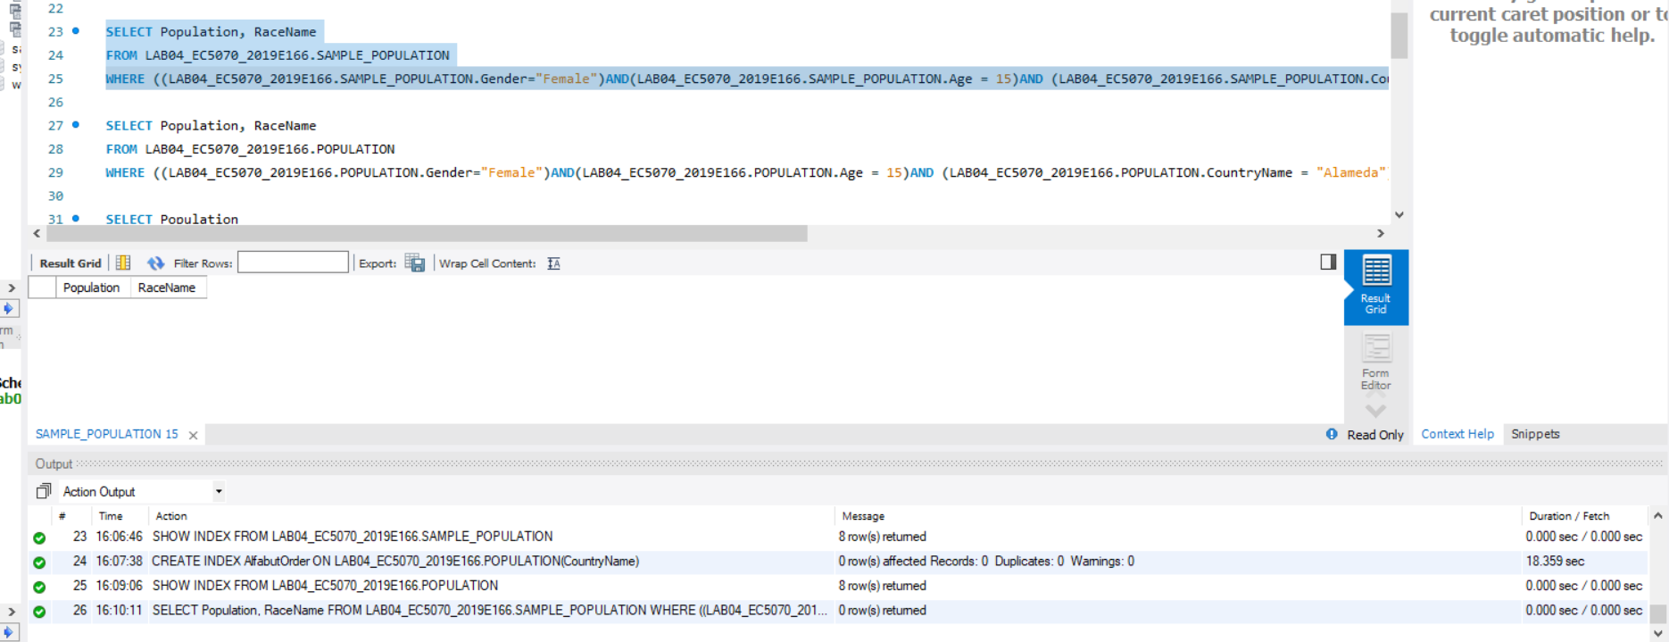

FIGURE 44 - QUERY 01 & TIME DURATION FOR SAMPLE POPULATION TABLE AFTER ADD PRIMARY KEY

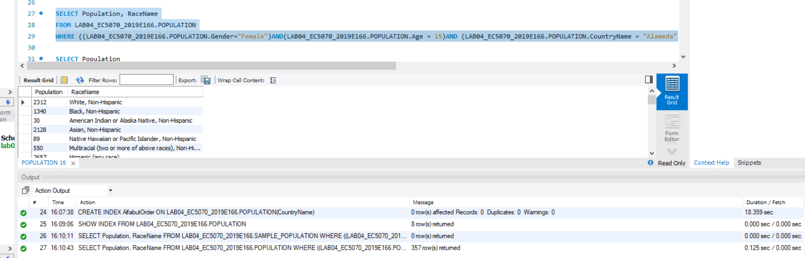

FIGURE 45 - QUERY 01 & TIME DURATION FOR POPULATION TABLE AFTER ADD PRIMARY KEY

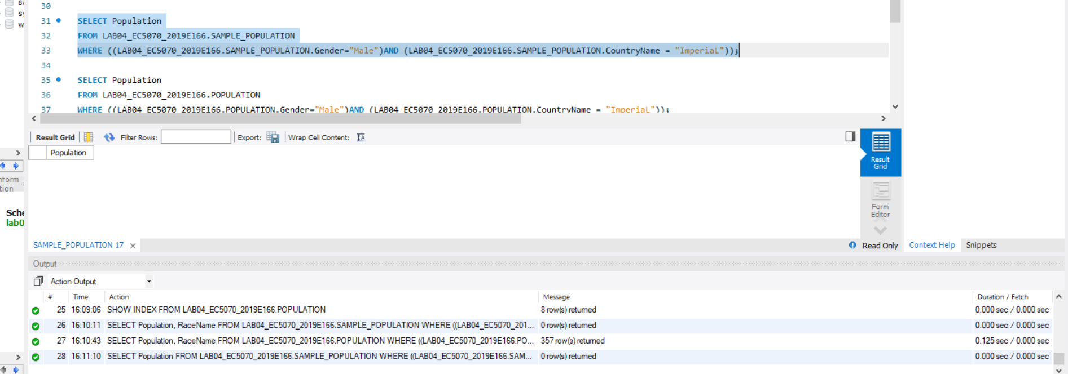

FIGURE 46 - QUERY 02 & TIME DURATION FOR SAMPLE POPULATION TABLE AFTER ADD PRIMARY KEY

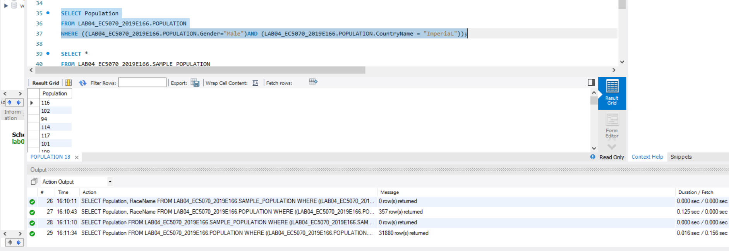

FIGURE 47 - QUERY 02 & TIME DURATION FOR POPULATION TABLE AFTER ADD PRIMARY KEY

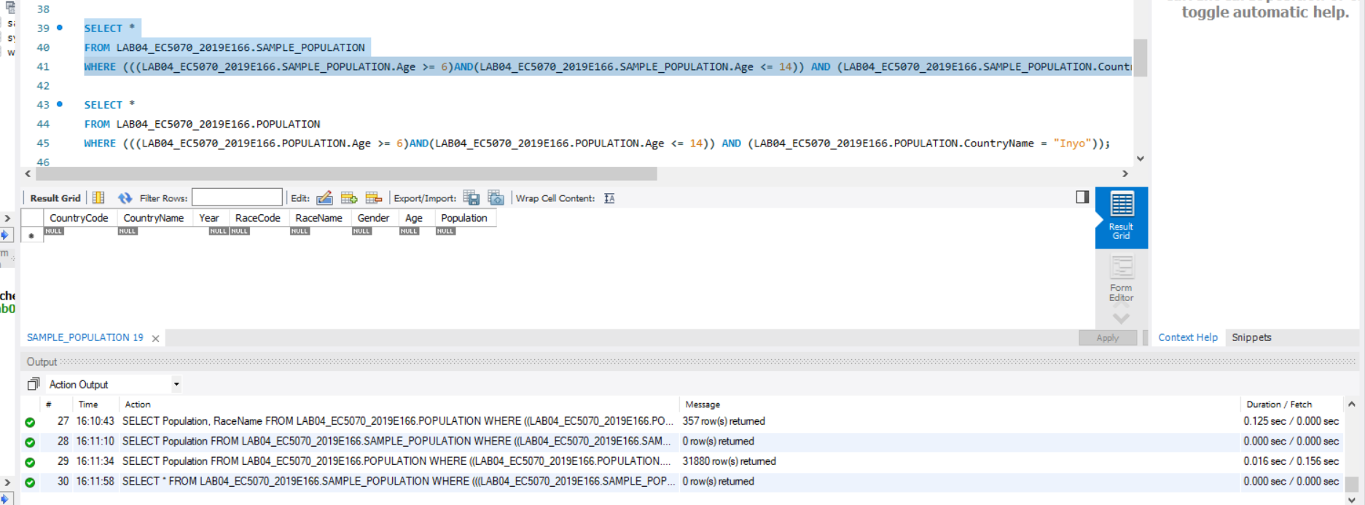

FIGURE 48 - QUERY 03 & TIME DURATION FOR SAMPLE POPULATION TABLE AFTER ADD PRIMARY KEY

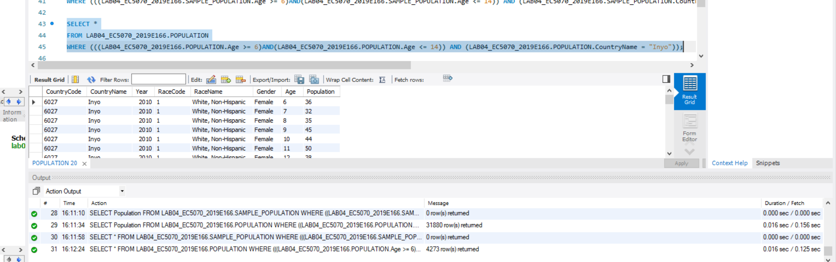

FIGURE 49 - QUERY 03 & TIME DURATION FOR POPULATION TABLE AFTER ADD PRIMARY KEY

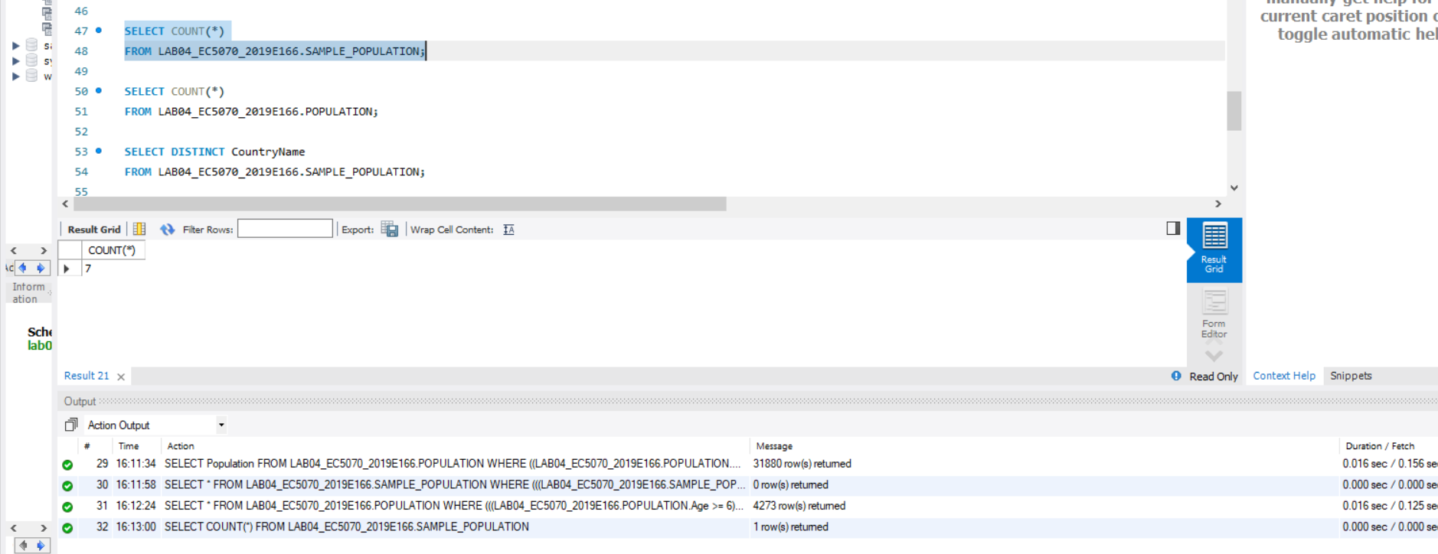

FIGURE 50 - QUERY 04 & TIME DURATION FOR SAMPLE POPULATION TABLE AFTER ADD PRIMARY KEY

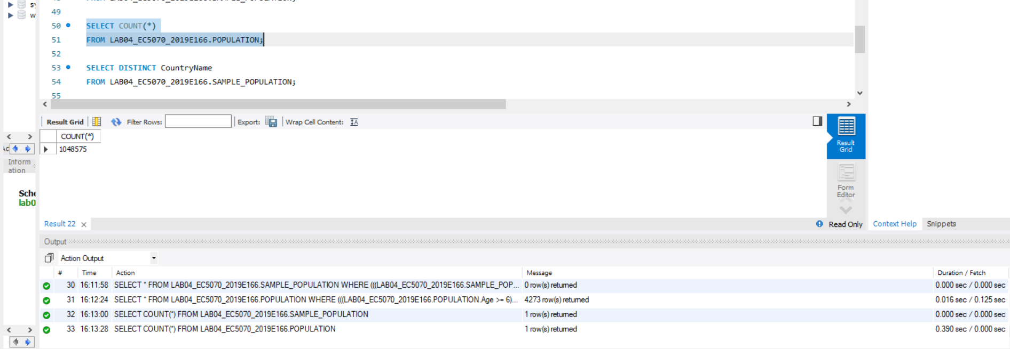

FIGURE 51 - QUERY 04 & TIME DURATION FOR POPULATION TABLE AFTER ADD PRIMARY KEY

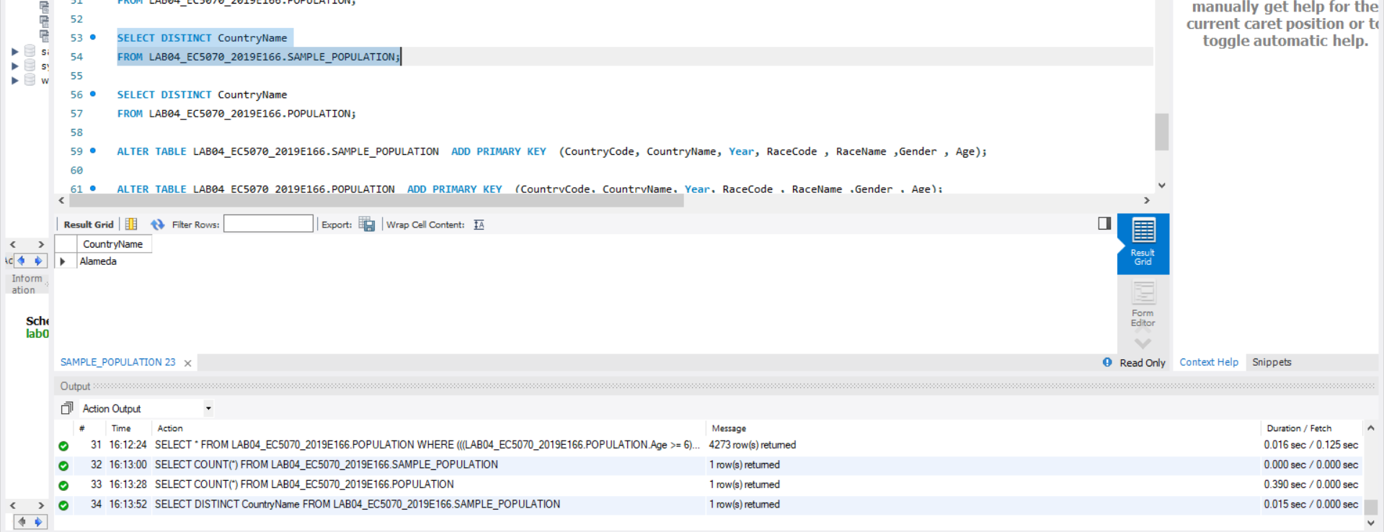

FIGURE 52 - QUERY 05 & TIME DURATION FOR SAMPLE POPULATION TABLE AFTER ADD PRIMARY KEY

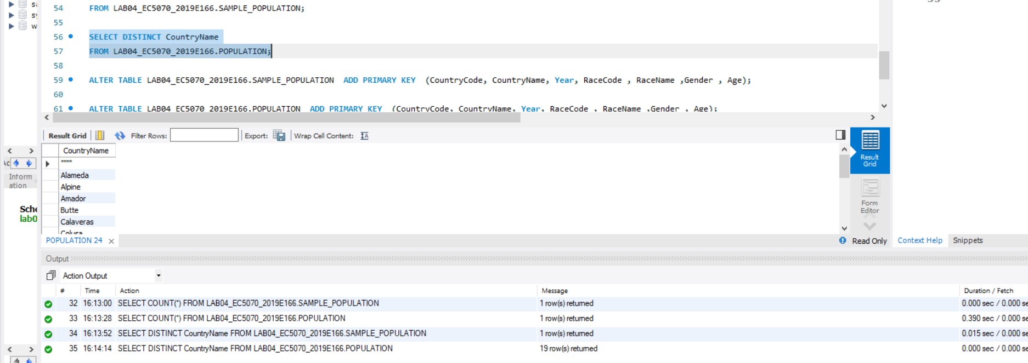

FIGURE 53 - QUERY 05 & TIME DURATION FOR POPULATION TABLE AFTER ADD PRIMARY KEY

09.

Time duration for find population and racename of data in table.

|  |  |  |
| --- | --- | --- |
|  | Time for Sample Population Table | Time for Population Table |
| Normal Query | 0.016 sec | 2.328 sec |
| After primary key add | 0.000 sec | 0.843 sec |
| After secondary index add | 0.000 sec | 0.125 sec |

Time duration for getting count of data in table.

|  |  |  |
| --- | --- | --- |
|  | Time for Sample Population Table | Time for Population Table |
| Normal Query | 0.000 sec | 0.468 sec |
| After primary key add | 0.000 sec | 0.594 sec |
| After secondary index add | 0.000 sec | 0.016 sec |

Time duration for getting count of data in table.

|  |  |  |
| --- | --- | --- |
|  | Time for Sample Population Table | Time for Population Table |
| Normal Query | 0.062 sec | 0.594 sec |
| After primary key add | 0.015 sec | 0.390 sec |
| After secondary index add | 0.000 sec | 0.016 sec |

Time duration for getting count of data in table.

|  |  |  |
| --- | --- | --- |
|  | Time for Sample Population Table | Time for Population Table |
| Normal Query | 1.812 sec | 2.204 sec |
| After primary key add | 0.000 sec | 0.110 sec |
| After secondary index add | 0.000 sec | 0.390 sec |

Time duration for getting count of data in table.

|  |  |  |
| --- | --- | --- |
|  | Time for Sample Population Table | Time for Population Table |
| Normal Query | 0.032 sec | 0.687 sec |
| After primary key add | 0.000 sec | 0.766 sec |
| After secondary index add | 0.015 sec | 0.000 sec |

When we study the upper tables we can see that most queries the time duration decrease step by step. When without any primary key or secondary index time duration is high the time after adding primary key is less than without query and the less time taken when secondary index added.

SQL QUERY

set Global local_infile=1;

CREATE DATABASE LAB04_EC5070_2019E166;

USE LAB04_EC5070_2019E166;

CREATE TABLE SAMPLE_POPULATION

(CountryCode INT, CountryName VARCHAR(20), Year YEAR, RaceCode INT,

RaceName VARCHAR(100),Gender VARCHAR(10) , Age INT , Population INT

);

CREATE TABLE POPULATION

(CountryCode INT, CountryName VARCHAR(20), Year YEAR, RaceCode INT,

RaceName VARCHAR(100),Gender VARCHAR(10) , Age INT , Population INT

);

LOAD DATA LOCAL INFILE 'E:\DataSheet/Samplepopulation.csv'

INTO TABLE SAMPLE_POPULATION FIELDS TERMINATED BY ',' ENCLOSED

BY '"' LINES TERMINATED

BY '\n' IGNORE 1 ROWS;

LOAD DATA LOCAL INFILE 'E:\DataSheet/Population.csv'

INTO TABLE POPULATION FIELDS TERMINATED BY ',' ENCLOSED

BY '"' LINES TERMINATED

BY '\n' IGNORE 1 ROWS;

SELECT Population, RaceName

FROM LAB04_EC5070_2019E166.SAMPLE_POPULATION

WHERE ((LAB04_EC5070_2019E166.SAMPLE_POPULATION.Gender="Female")AND(LAB04_EC5070_2019E166.SAMPLE_POPULATION.Age = 15)AND (LAB04_EC5070_2019E166.SAMPLE_POPULATION.CountryName = "Alameda"));

SELECT Population, RaceName

FROM LAB04_EC5070_2019E166.POPULATION

WHERE ((LAB04_EC5070_2019E166.POPULATION.Gender="Female")AND(LAB04_EC5070_2019E166.POPULATION.Age = 15)AND (LAB04_EC5070_2019E166.POPULATION.CountryName = "Alameda"));

SELECT Population

FROM LAB04_EC5070_2019E166.SAMPLE_POPULATION

WHERE ((LAB04_EC5070_2019E166.SAMPLE_POPULATION.Gender="Male")AND (LAB04_EC5070_2019E166.SAMPLE_POPULATION.CountryName = "ImperiaL"));

SELECT Population

FROM LAB04_EC5070_2019E166.POPULATION

WHERE ((LAB04_EC5070_2019E166.POPULATION.Gender="Male")AND (LAB04_EC5070_2019E166.POPULATION.CountryName = "ImperiaL"));

SELECT *

FROM LAB04_EC5070_2019E166.SAMPLE_POPULATION

WHERE (((LAB04_EC5070_2019E166.SAMPLE_POPULATION.Age >= 6)AND(LAB04_EC5070_2019E166.SAMPLE_POPULATION.Age <= 14)) AND (LAB04_EC5070_2019E166.SAMPLE_POPULATION.CountryName = "Inyo"));

SELECT *

FROM LAB04_EC5070_2019E166.POPULATION

WHERE (((LAB04_EC5070_2019E166.POPULATION.Age >= 6)AND(LAB04_EC5070_2019E166.POPULATION.Age <= 14)) AND (LAB04_EC5070_2019E166.POPULATION.CountryName = "Inyo"));

SELECT COUNT(*)

FROM LAB04_EC5070_2019E166.SAMPLE_POPULATION;

SELECT COUNT(*)

FROM LAB04_EC5070_2019E166.POPULATION;

SELECT DISTINCT CountryName

FROM LAB04_EC5070_2019E166.SAMPLE_POPULATION;

SELECT DISTINCT CountryName

FROM LAB04_EC5070_2019E166.POPULATION;

ALTER TABLE LAB04_EC5070_2019E166.SAMPLE_POPULATION ADD PRIMARY KEY (CountryCode, CountryName, Year, RaceCode , RaceName ,Gender , Age);

ALTER TABLE LAB04_EC5070_2019E166.POPULATION ADD PRIMARY KEY (CountryCode, CountryName, Year, RaceCode , RaceName ,Gender , Age);

CREATE INDEX AlfabutOrder ON LAB04_EC5070_2019E166.SAMPLE_POPULATION(CountryName);

SHOW INDEX FROM LAB04_EC5070_2019E166.SAMPLE_POPULATION;

CREATE INDEX AlfabutOrder ON LAB04_EC5070_2019E166.POPULATION(CountryName);

SHOW INDEX FROM LAB04_EC5070_2019E166.POPULATION;